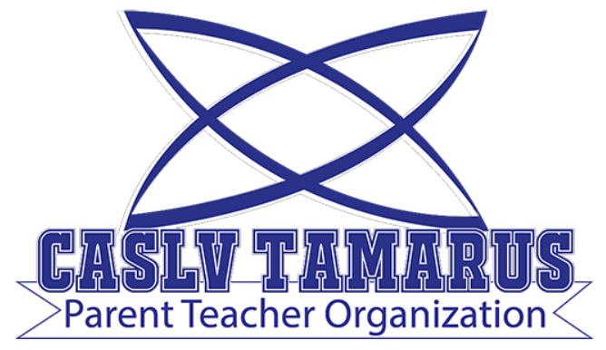 | Meeting Agenda

Meeting Date: November 2, 2021
Meeting Time: 6:00 pm
Meeting Location: Meeting held remotely via zoom
Zoom Invitation and Link: TBA

Your Tamarus PTO:
Jennifer Andreevski (President)
Stacy Wallace (Treasurer)
Carryn Warren (Secretary)

- Call to Order
- Roll Call and Introductions
- Treasurer’s Report
- Updates/Announcements:
  - End of quarter teacher breakfast
  - Trunk or treat
  - Spirit shirts and hoodies
- Discussion of Potential Activities
  - Fundraisers in November/December
  - Holiday/winter gifts for teachers/staff
- Questions and Answers session with Principal Katotakis
- Public Comment
- Next meeting: December 7, 2021 at 6:00 pm (held remotely)

